**SU92-BSAIM-F24-035**

**AI-LAB 3A**

**TASK 01**

**DYNAMIC CALCULATOR** (solving: 1+2×3(4-5÷4) - (3÷5))

Can be create by two ways:

* Basic input method
* Ipywidgets sliders Version

**1.Basic Input Method Uses steps:**

**(1+2×3(4-5÷4) - (3÷5)) to 1 + 2 * 3 * (4 - 5/4) - (3/5)**

1. Evaluate the innermost division:

5/4 = 1.25 (exactly 5/4).

1. Compute inside the parentheses:

4 - 5/4 = 4 - 1.25 = 2.75 — exactly 16/4 - 5/4 = 11/4.

1. Multiply by 3:

3 × (11/4) = 33/4 = 8.25.

1. Multiply that by 2:

2 × 33/4 = 66/4 = 33/2 = 16.5.

1. Evaluate the final parenthesis:

3/5 = 0.6 (exactly 3/5).

1. Now do addition/subtraction left-to-right:

1 + 16.5 = 17.5

17.5 - 0.6 = 16.9

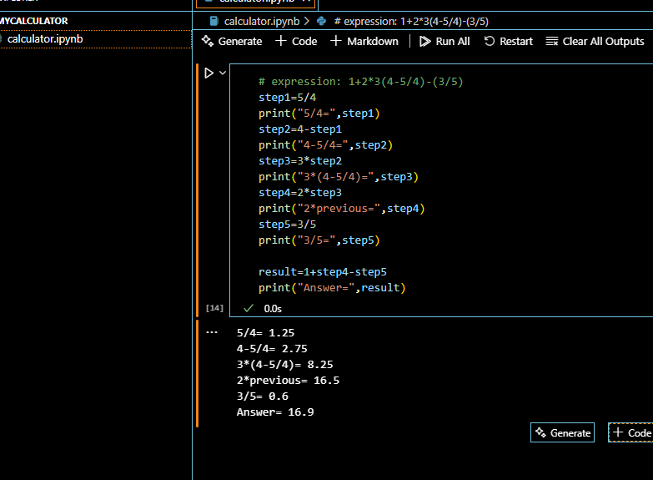

**Description:**

Entire mathematical expression in one line **(1+2×3(4-5÷4)-(3÷5)).**

Normalizes the special symbols and fixing them like * into multiply.

The normalized expression is safely evaluated using Python to compute the result.

Multiple operators, parentheses, brackets, and complex expressions in a single step.

Displays the **final result instantly** (for the given input the output is **16.9)**

**2.Ipywidgets Sliders Version Use Libraries:**

* **ipywidgets**

**What it is:** A Python library for interactive widgets in Jupyter/Colab.  
 **used:** To control variables with sliders, buttons, dropdowns, etc.

* **Interact**

**What it is:** A function that auto-creates widgets for function inputs.  
**used:** results update live when moving a slider or changing input.

* **FloatSlider**

**What it is:** A slider widget for decimal numbers (floats).  
**used:** To pick values in a range with steps (e.g., 0.1, 0.2, 0.3).

***Steps:***

1.Inner Division: 5 ÷ 4 = 5/4 = 1.25

2. Parentheses: (4 - 5/4) = 11/4 = 2.75

3. Multiply by x3: 3 × (4 - 5/4) = 33/4 = 8.25

4. Multiply by x2: 2 × [3 × (4 - 5/4)] = 33/2 = 16.5

5. Division: (3 ÷ 5) = 3/5 = 0.6

6. Final Expression: 1 + (2×3×(4-5/4)) - (3/5) = 169/10 = 16.9

,

l.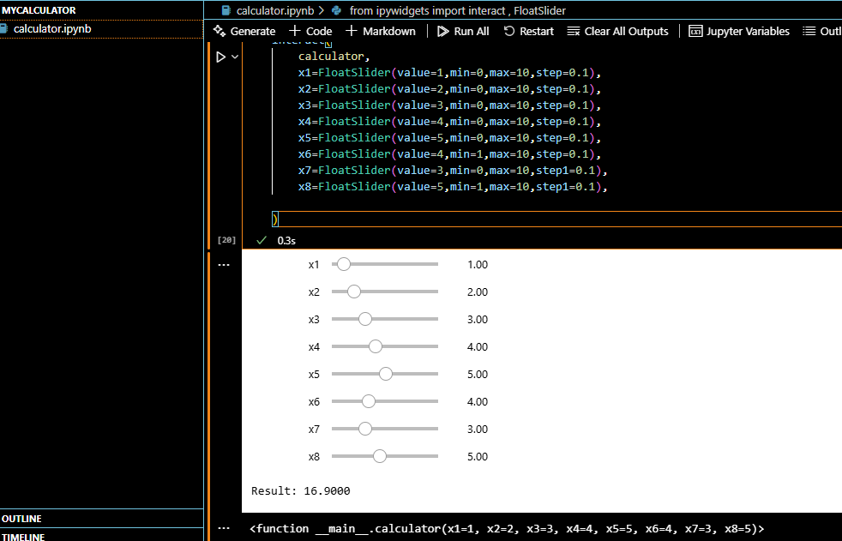

**Description:**

Firstly , convert **1+2×3(4-5÷4)-(3÷5)to x1+x2×x3×(x4−x6/x5​)−(x8/x7​)**

**Sliders with** interact like dragging x5 from 5 → 6 recalculates the whole formula live

**Special notes:** x6 and x8 sliders have **min=1** to avoid **division by zero**. You can adjust the range (0–10) and step (0.1) of each slider.

This code builds an **interactive dynamic calculator** for the expression x1 + x2×x3(x4 - x5/x6) - (x7/x8) where each variable is **controlled by a** **slider**.